James Keller – GES408 – Lab 2
- Produce of a histogram of the raw data and describe the pattern. (Is it normally distributed? Skewed? Etc.)
The sampled data is positively skewed.
  - Hint: you can change the axes labels of a plot in JASP by clicking on the down arrow next to the bolded word right above the plot and going to "edit image". Remember to hit the enter key!
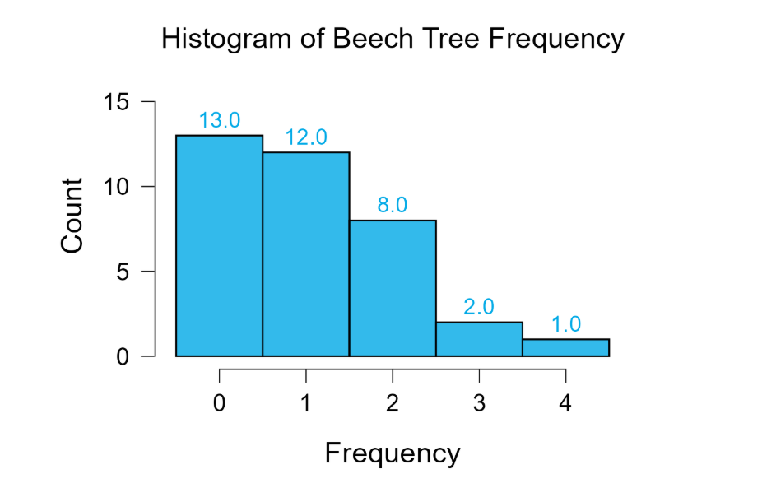
- What is the mean and variance? Are they similar?
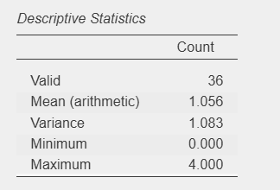
The mean and variance are similar.
- Produce a histogram of the expected number of quadrats per individuals (so, for the probability of getting x individuals, multiply that by the total number of quadrats sampled).
- This will be the part that takes you the longest.
- We sampled plots, and they had between 0 and X individuals of interest in them.
- You have the mean number of individuals in a plot, and the formula for a Poisson Random Variable.
- You will want to figure out the probability of getting 0 individuals in a plot, getting 1 individual in a plot, 2 individuals in a plot, up to X individuals in a plot.
- Given those probabilities, if we had Y plots, how many of those would we have expected to have 0 individuals in them? 1? 2? X?
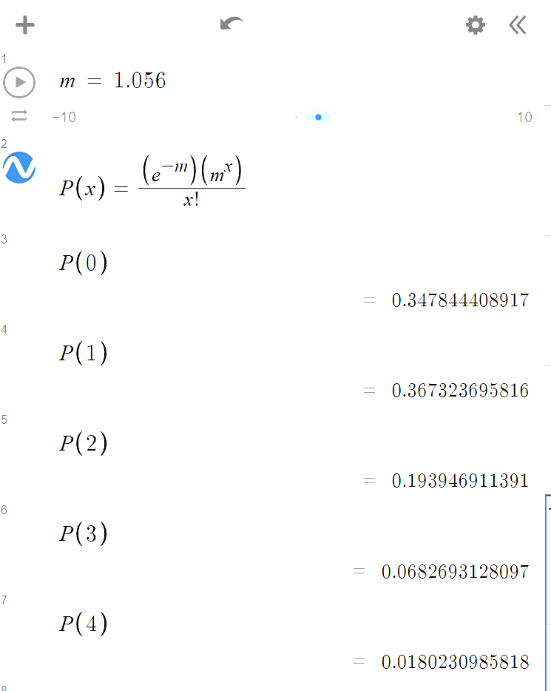
In my calculations, m represents the sample mean.
- Create a new column in your JASP dataset with these numbers. (Just like your count column, but it's expected counts - if we expect 10 plots to have no individuals in them, there should be 10 zeroes in that column.)
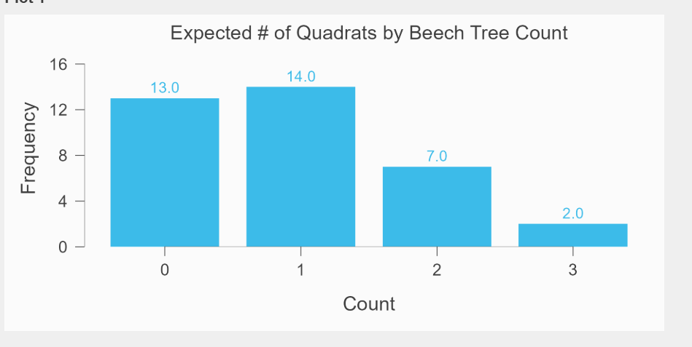
- Compare the two histograms. The one generated assuming a Poisson process suggests individuals are randomly distributed. Do you think they are? Why/why not?
The histogram generated assuming a Poisson process does assume the process is random. I believe that this is true but due to our relatively small sample size it is not as apparent. As you increase the amount of hypothetical sampled plots, the graph begins to look more and more like the normal distribution. Also, because we cannot have a negative amount of beech trees in a plot part of our distribution is cut off.

- You can also look back at your expected quadrats per individuals vs the actual, if you would like.

